|  |
| --- |
| Nanyang Polytechnic   Centre for IT Innovation  User Guide  For  Sea Transportation E Portal Services (STEPS)  Web Portal  Version 0.1 |

@ Copyright Nanyang Polytechnic 2020

This copyright in this work belongs to Nanyang Polytechnic. The information contained in this work is confidential and must not be reproduced or disclosed to others without the prior written permission of Nanyang Polytechnic.

**DOCUMENT CONTROL**

|  |  |  |  |
| --- | --- | --- | --- |
| **Version** | **Date** | **Prepared By** | **Changes From Previous Version** |
| 0.1 | 07-Sep-2020 | Cally Ng | First Draft |

Table of Contents

1 Purpose 4

2 Getting Started 4

3 User Role 4

3.1 Administrator 4

3.2 Moderator 5

4 FUNCTIONAL GUIDE 6

4.1 Login 6

4.2 Forget password 8

4.3 Act on Inbox 10

*4.3.1* Approve New/Inappropriate Reviews 10

*4.3.2* Reject New/Inappropriate Reviews 13

4.4 Manage Profile 14

*4.4.1* View Profile 14

*4.4.2* Update Profile 15

*4.4.3* Change password 17

4.5 Manage User 20

*4.5.1* Create User Record 20

*4.5.2* Manage Users 22

*4.5.3* View User Record 23

*4.5.4* Edit User Record 24

*4.5.5* Delete User Record 25

*4.5.6* Reset User’s Password 26

4.6 Manage Settings 27

4.7 Manage Reviews 31

*4.7.1* Search Reviews 31

*4.7.2* View Reviews 33

*4.7.3* Edit Review 34

*4.7.4* Reject Review 36

4.8 Download Report 37

4.9 Logout 42

# Purpose

This document provides step by step instructions on the features provided by Sea Transportation E Portal Services (STEPS) – Web Portal.

# Getting Started

To start using STEPS – Web Portal, it is recommended that your computer have the following settings:

* Google Chrome 85.0 or later.
* Screen resolution is 1024 by 768 pixels or more.

# User Role

For web portal, there will be only one user role – administrator.

## Administrator

Administrator is the key user of this website. He/she has the “super user” access to STEPS. Administrator can access the following functions:

* Login
* Change Password
* Forget Password
* Act On Inbox
* Manage Review
* Edit Review
* Manage Settings
* Create Users
* Manage User
* Download Report

## Moderator

Moderator can only access part of the Administrator’s functions:

* Login
* Change Password
* Forget Password
* Act On Inbox
* Manage Review

# FUNCTIONAL GUIDE

## Login

Only authenticate Moderators and Administrators are allowed to use the system function.

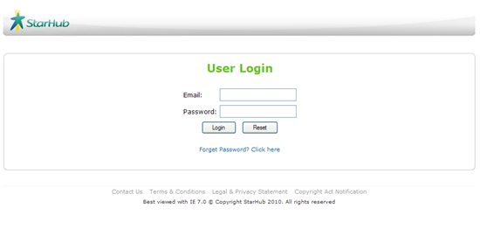

Figure 4.1.1: Login page

Step 1: In the ***Email*** textbox, enter your email.

Step 2: In the ***Password*** textbox, enter your password.

Step 3: Click on the ***Login*** button.

Authorized user will be directed to the default Inbox page (Figure 4.1.2).

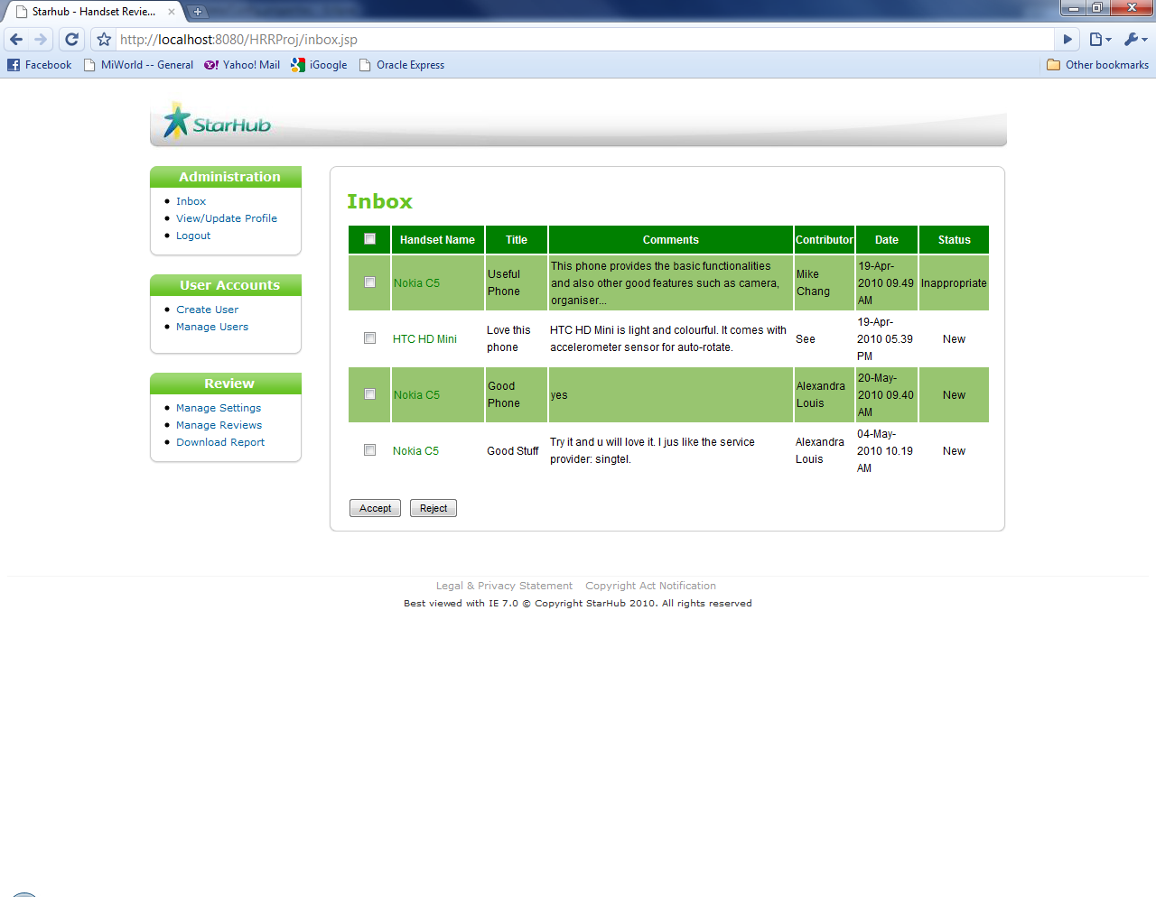

Figure 4.1.2: Inbox page

## 

## Forget password

Step 1: On the ***Login*** page, click on ***Forget Password*** hyperlink.



Figure 4.2.1: *Forget Password* hyperlink

Forget Password page will appear (Figure 4.2.2).

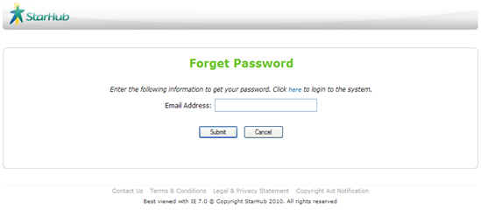

Figure 4.2.2: Forget password page

Step 2: In the ***Email Address*** textbox, enter your email address.

Step 3: Click on **Submit** button *(Figure 4.2.3)*.

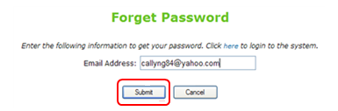

Figure 4.2.3: Forget password

## Act on Inbox

Inbox contains the new posted reviews. Moderators could approve or reject the new reviews.

### Approve New/Inappropriate Reviews

Step 1: On the ***Administration*** menu bar, click on ***Inbox*** *(Figure 4.3.1.1)*.



Figure 4.3.1.1: Inbox page

Step 2: On the ***Inbox*** page, tick on the checkbox to select review to approve.

Step 3: Click on ***Accept*** button to approve the review.



Figure 4.3.1.2: Approve Review

|  |
| --- |
| **Tip:** You can tick on the first check box from the top to approve all reviews at one go  *(Figure 4.3.1.3)*.    Figure 3.1.3: Approve all reviews |

|  |
| --- |
| **Note:** You can click on a particular ***Handset Name*** to view and make changes to the details of the review before approving the review *(Figure 4.3.1.4)*.    Figure 3.1.4: *Handset Name* |

### Reject New/Inappropriate Reviews

Step 1: On the ***Inbox*** page, tick on the checkbox*(Figure 4.3.2.1)*.

Step 2: Click on ***Reject*** button to reject the review.



Figure 4.3.2.1: Reject Review

Step 3: Click on the ***OK*** button to confirm *(Figure 4.3.2.2)*.

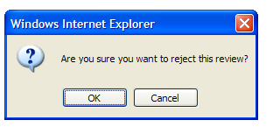

Figure 4.3.2.2: Reject review

An email will be sent to the contributor if review rejected due to inappropriate content.

## Manage Profile

This function allows the administrator or moderator to maintain his own user profile.

### View Profile

Step 1: On the ***Administration*** menu bar, click on ***View/Update Profile,*** the user profile will automatically displayed*(Figure 4.4.1.1)*.

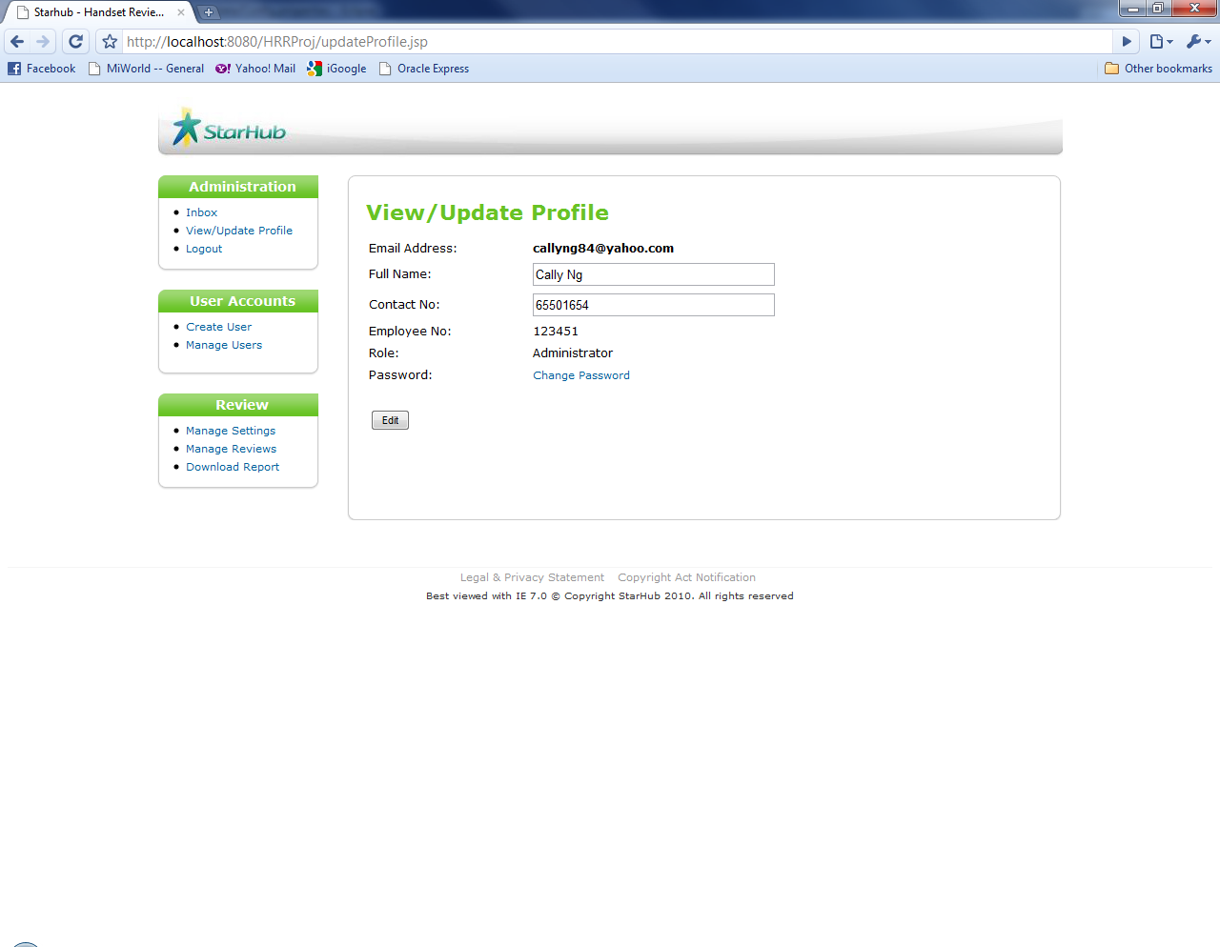

Figure 4.4.1.1: View/Update Profile page

### Update Profile

Step 1: In the ***Full Name*** textbox, edit name.

Step 2: In the ***Contact No*** textbox, edit contact number.

Step 3: Click on ***Edit*** button to update profile *(Figure 4.4.2.1)*.

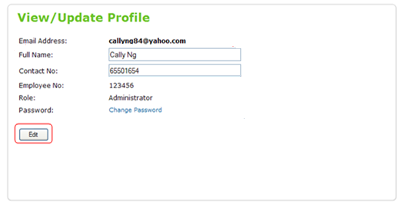

Figure 4.4.2.1: Update profile

Asuccessful update of profile message will be shown (Figure 4.4.2.2).

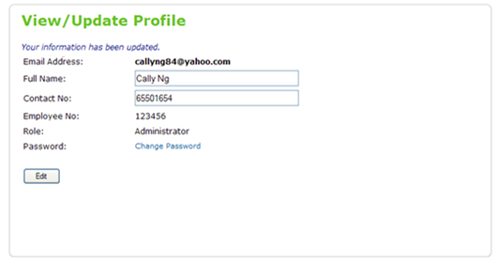

Figure 4.4.2.2: Successful Update of Profile message

### Change password

Step 1: Click on ***Change Password*** hyperlink to change password *(Figure 4.4.3.1)*.

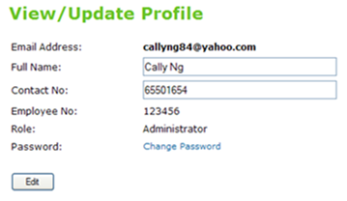

Figure 4.4.3.1: *Change Password* hyperlink

The page will be directed to Change Password page (Figure 4.4.3.2).

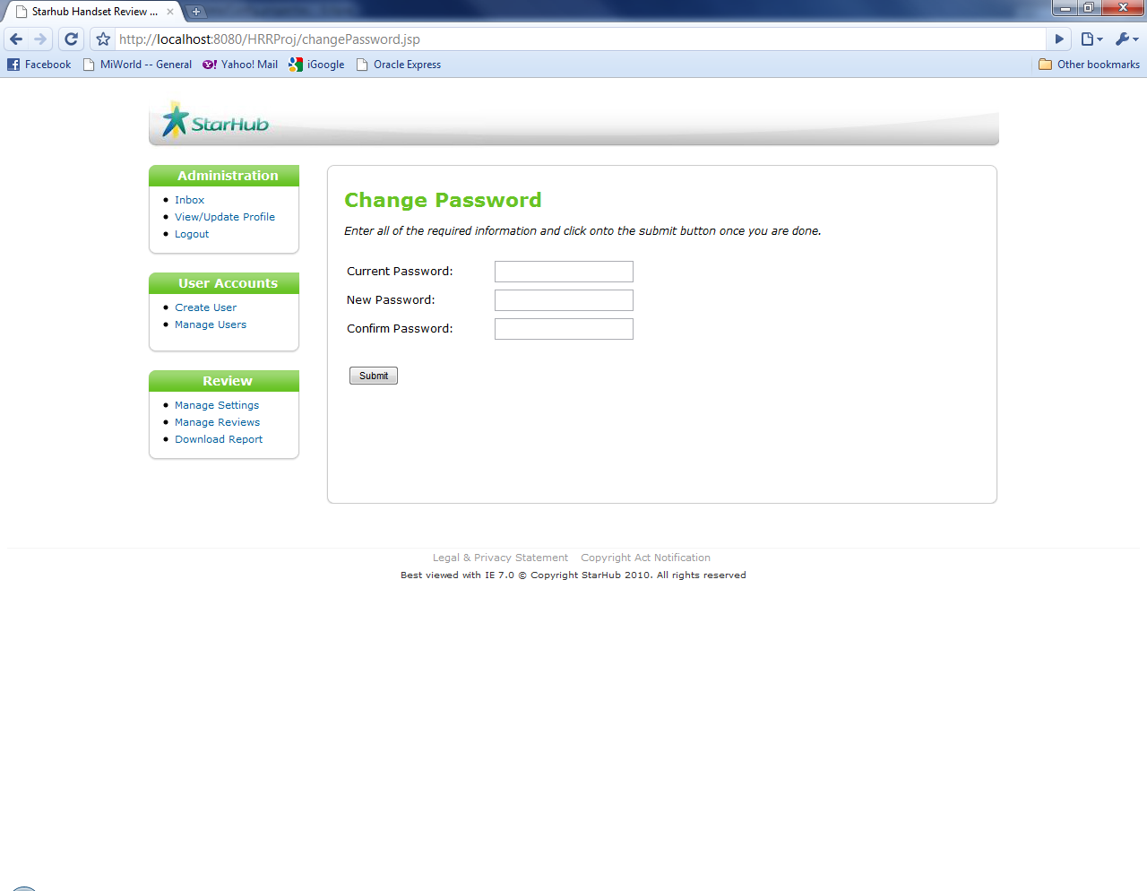

Figure 4.4.3.2: Change Password page

Step 2: In the ***Current Password*** textbox, enter current password.

Step 3: In the ***New Password*** textbox, enter new password.

Step 4: In the ***Confirm Password*** textbox, enter new password again.

|  |
| --- |
| **Note:** The password must be a minimum of 6 alphanumeric characters long. |

Step 5: Click on ***Submit*** button to change password *(Figure 4.4.3.3)*.

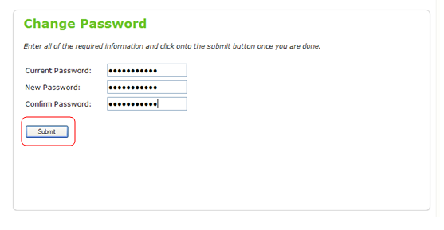

Figure 4.4.3.3: Change password

Asuccessful update of password message will be shown (Figure 4.4.3.4).

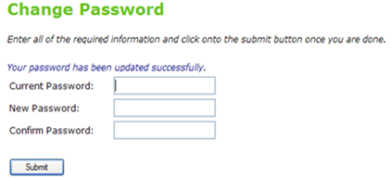

Figure 4.4.3.4: Successful Update of Password message

## Manage User

This function allows the administrator to create a new user or update an existing user record.

### Create User Record

Step 1: On the ***User Accounts*** menu bar, click on ***Create User*** *(Figure 4.5.1.1)*.

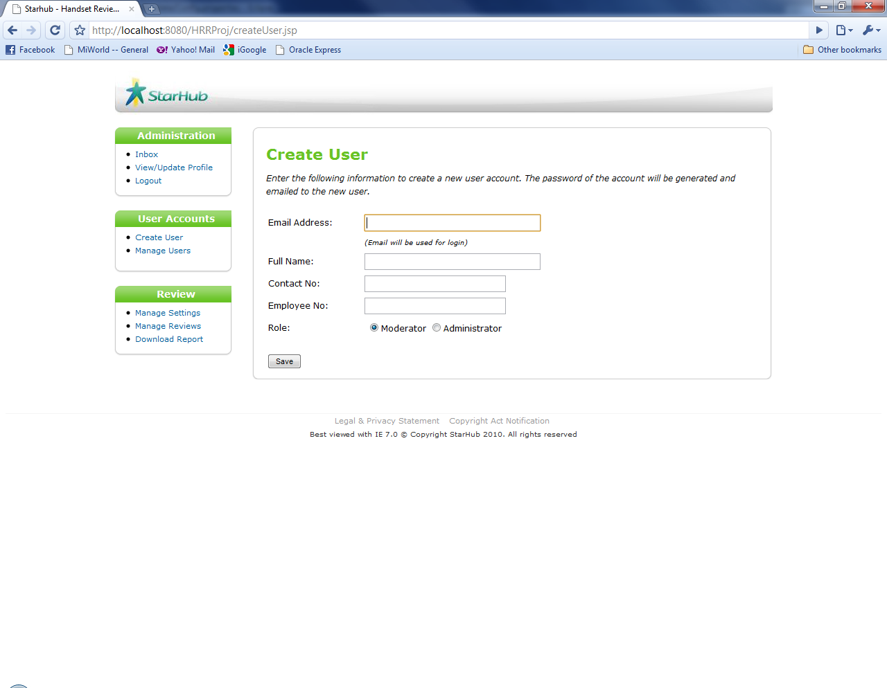

Figure 4.5.1.1: Create User page

Step 2: In the ***Email Address*** textbox, enter email address.

Step 3: In the ***Full Name*** textbox, enter name.

Step 4: In the ***Contact No*** textbox, enter contact number.

Step 5: In the ***Employee No*** textbox, enter employee number.

Step 6: In the ***Role*** radio button, check role.

Step 7: Click on ***Save*** button to create user *(Figure 4.5.1.2)*.

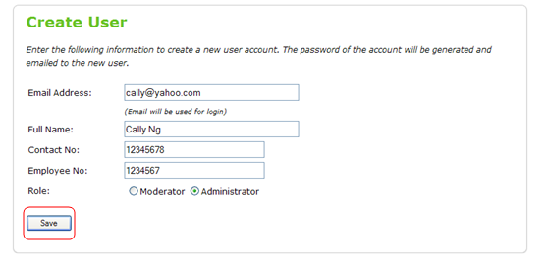

Figure 4.5.1.2: Create user record

### Manage Users

Step 1: On the ***User Accounts*** menu bar, click on ***Manage Users*** *(Figure 4.5.2.1)*.

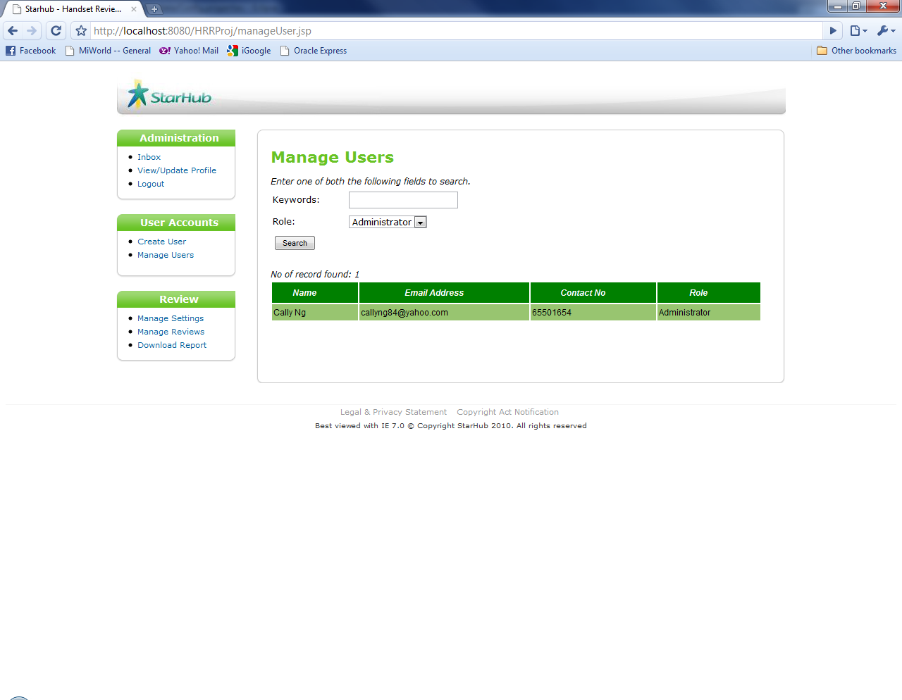

Figure 4.5.2.1: Search User page

Step 1: In the ***Keywords*** textbox, enter the searched name.

Step 2: Select a ***Role*** from the drop down list.

Step 3: Click on ***Search*** button to search for user

The results will be displayed with number of records found shown (Figure 4.5.2.1).

### View User Record

Click on the ***Name*** in user list *(Figure 4.5.3.1)*.



Figure 4.5.3.1: Name hyperlink

The page will be directed View/Edit User Record page (Figure 4.5.3.2).

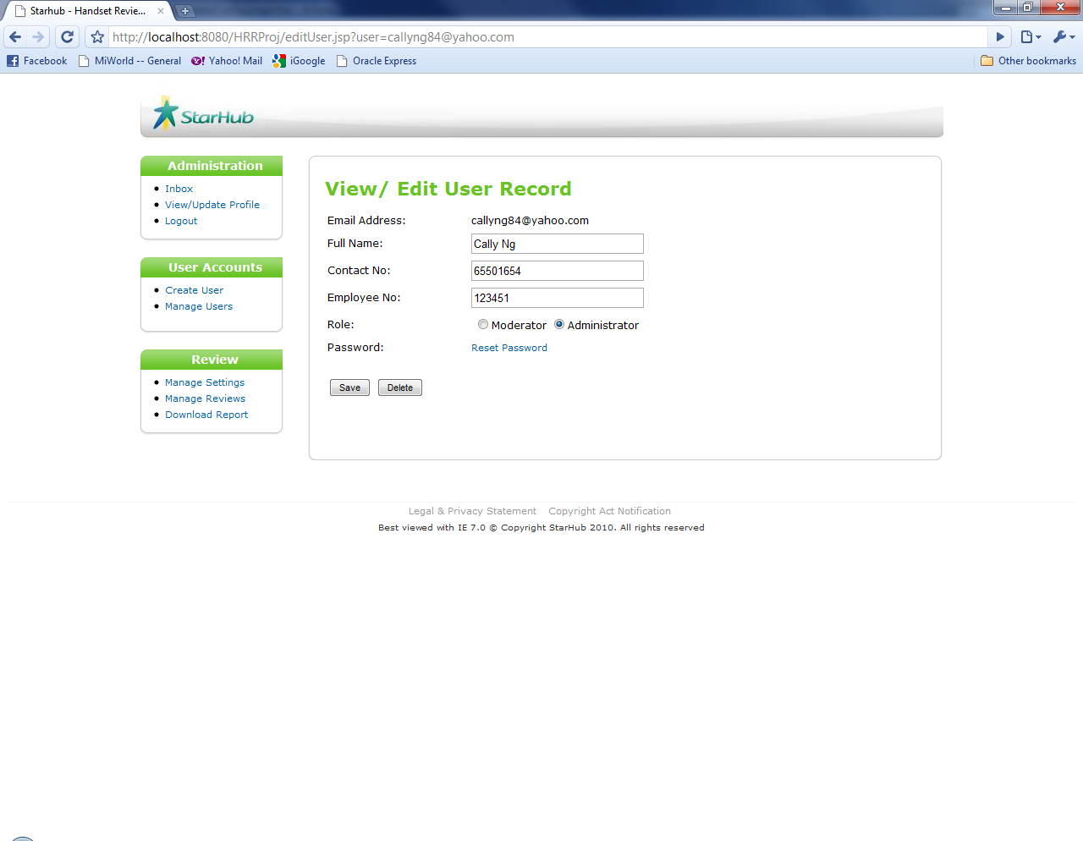

Figure 4.5.3.2: View/Edit User Record page

### Edit User Record

Step 1: In the ***Full Name*** textbox, edit name.

Step 2: In the ***Contact No*** textbox, edit contact number.

Step 3: In the ***Employee No*** textbox, edit employee number.

Step 4: Click on the radio button to edit the role of the user.

Step 5: Click on ***Edit*** button to edit user record *(Figure 4.5.4.1)*.

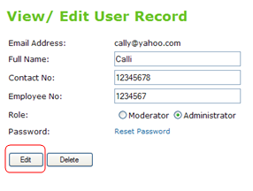

Figure 4.5.4.1: Edit user record

A successful update of user information message will be shown (Figure 4.5.4.2).

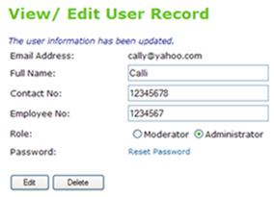

Figure 4.5.4.2: Successful Update of User Information message

### Delete User Record

Step 1: Click on ***Delete*** button to delete user record *(Figure 4.5.5.1)*.

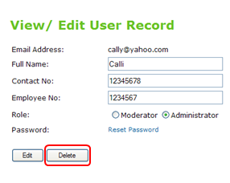

Figure 4.5.5.1: Delete button

Step 2: Click on the ***OK*** button to confirm *(Figure 4.5.5.2)*.

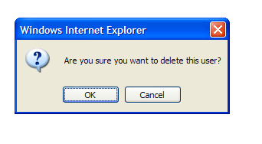

Figure 4.5.5.2: Delete user

The user record will be deleted and the page will be directed back to Search User page.

### Reset User’s Password

Click on ***Reset Password*** hyperlink to reset user’s password *(Figure 4.5.6.1)*.

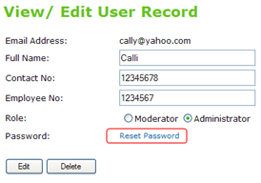

Figure 4.5.6.1: *Reset Password* hyperlink

An email will be sent to the contributor if review rejected.

## Manage Settings

This function allows the administrator to configure application setting for the following:

* Determine the review sorting order in the consumer review module. Administrator can choose to sort the review by review date in descending order or by rating in descending order.
* Threshold value of inappropriate reporting. For any review that was reported as inappropriate and exceed the threshold, system will set the particular review to red flag
* Blacklist keywords on the review comment. System will set a new review to blacklisted when it contain the blacklist keywords.

Step 1: On the ***Review*** menu bar, click on ***Manage Settings*** *(Figure 4.6.1)*.

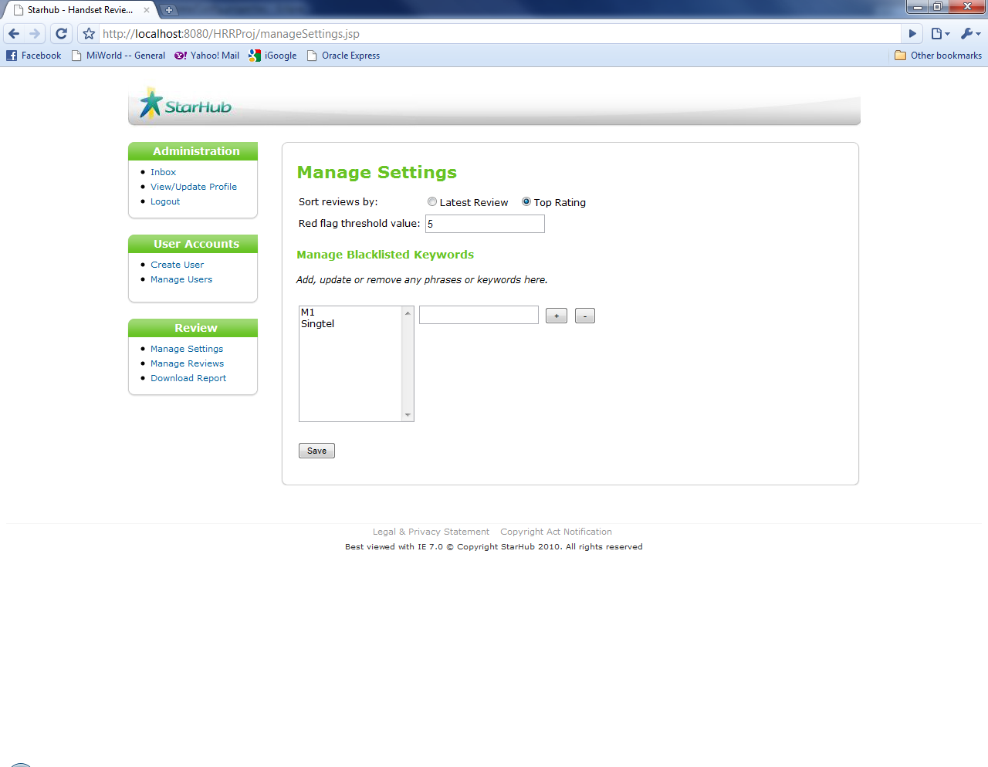

Figure 4.6.1: Manage Settings page

Step 2: In the ***Sort reviews by*** radio buttons, check required review sorting *order*.

Step 3: In the ***Red flag threshold value*** textbox, enter red flag threshold value

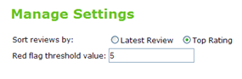

Figure 4.6.2: Manage Settings section

Step 4: In the ***Manage Blacklisted Keywords*** section, add, update or remove any phrases or keywords.

In the textbox, enter one phrase or keyword, click on the“***+***” sign button to add the phrase or keyword *(Figure 4.6.3)*.



Figure 4.6.3: “+” sign button

To remove the phrase or keyword, select the keywords in the list and click on the“***-***” sign button *(Figure 4.6.4)*.

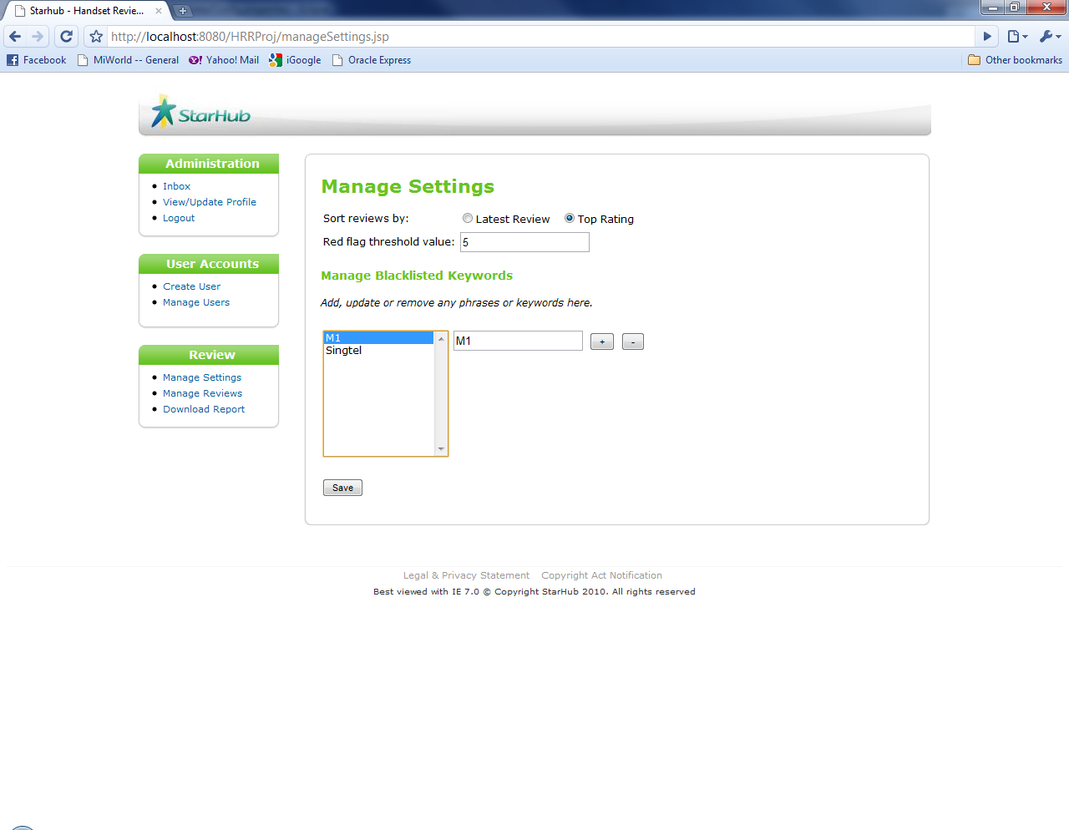

Figure 4.6.4: “-” sign button

Step 5: Click on ***Save*** button to save settings *(Figure 4.6.6)*.



Figure 4.6.6: Save Settings

Asuccessful update message will be shown (Figure 4.6.7).

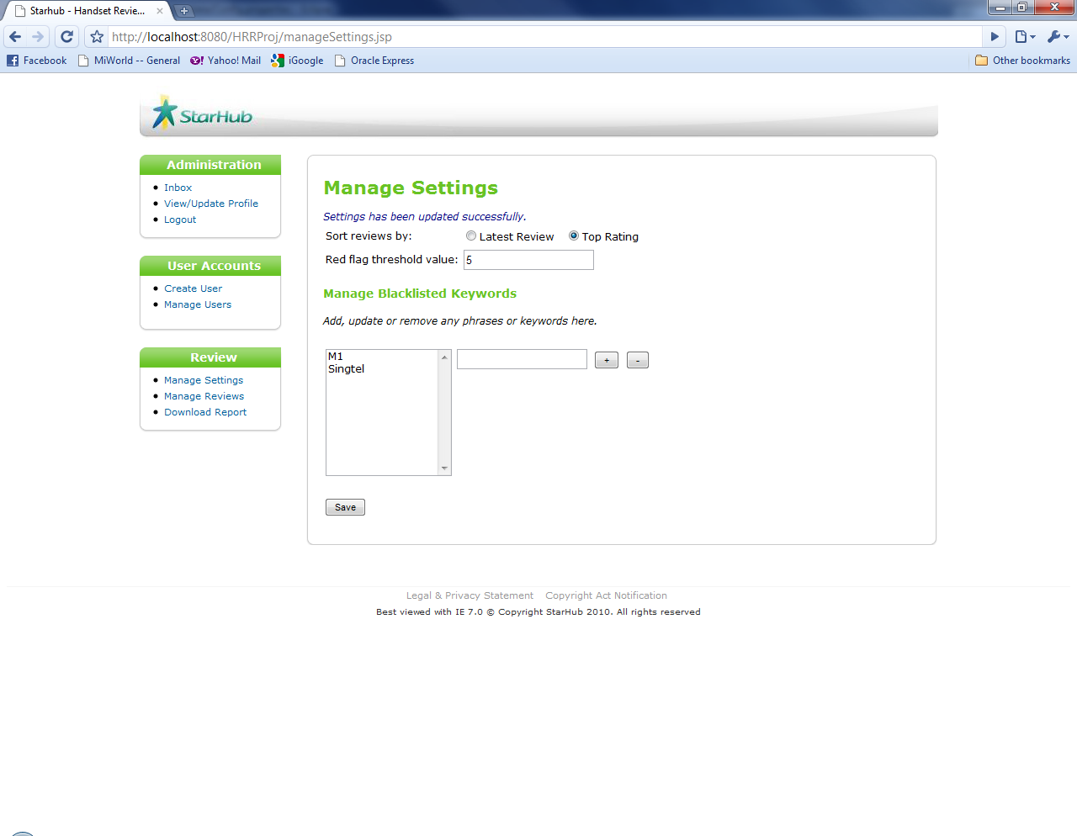

Figure 4.6.7: Successful Update of Settings message

## Manage Reviews

This function allows the administrator to change the status and moderate the content of the reviews.

### Search Reviews

Step 1: On the ***Review*** menu bar, click on ***Manage Reviews*** *(Figure 4.7.1.1)*.

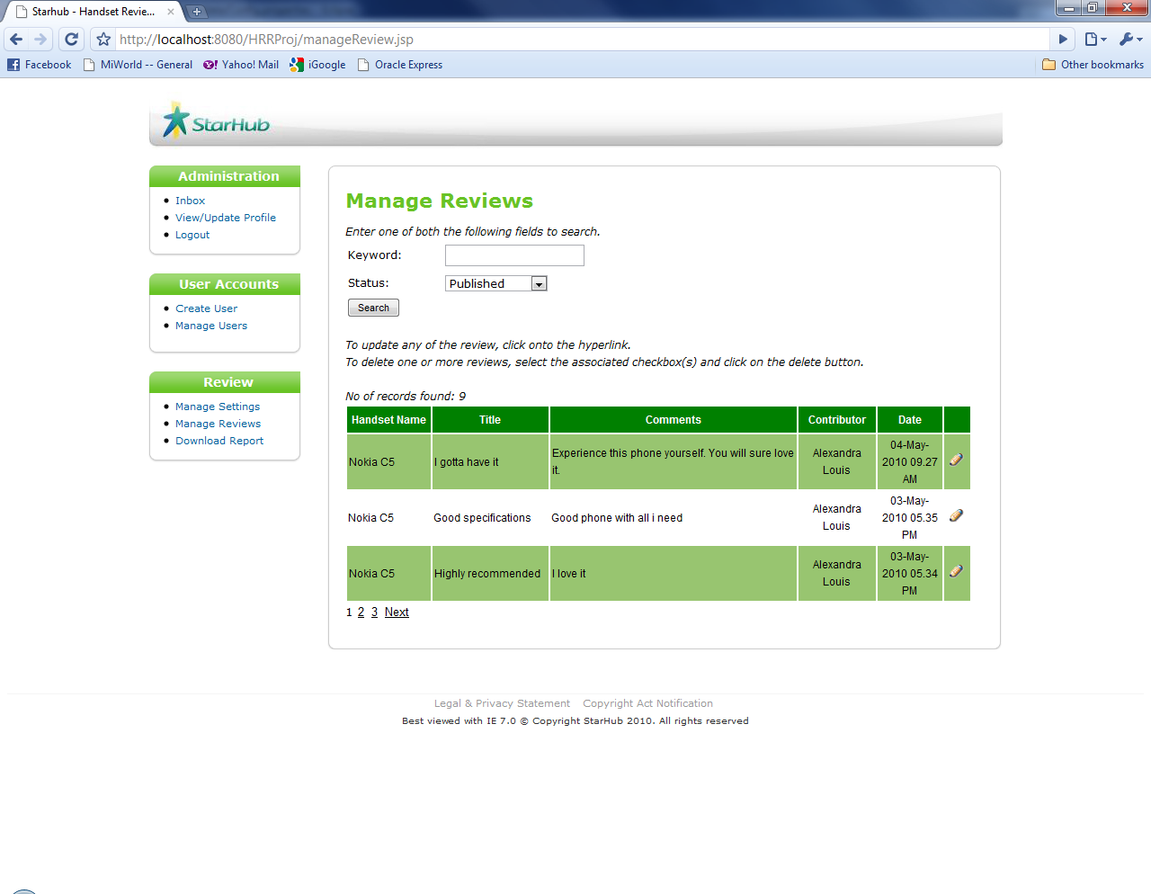

Figure 4.7.1.1: Manage Reviews page

Step 2: In the ***Keyword*** textbox, enter keyword.

Step 3: Select a ***Status*** from the dropdown list.

Step 4: Click on ***Search*** button to search for reviews *(Figure 4.7.1.2)*.

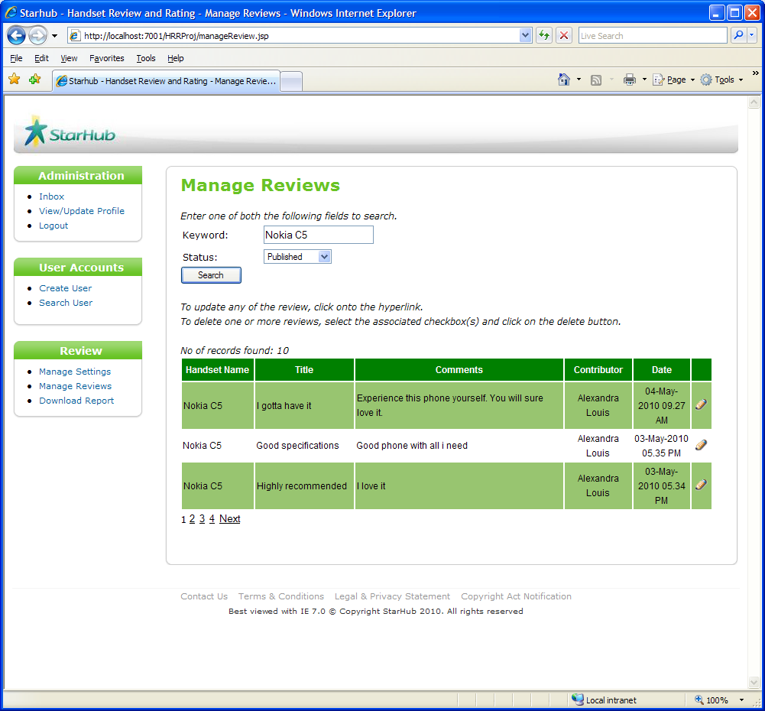

Figure 4.7.1.2: Search for review

The results will be displayed with number of records found shown (Figure 4.7.1.3).

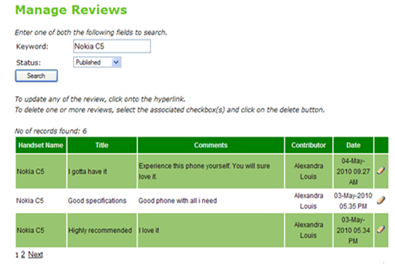

Figure 4.7.1.3: Searched results

### View Reviews

Step 1: On the *Searched results section*, click on the  icon *(Figure 4.7.2.1)*.

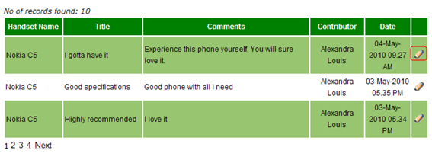

Figure 4.7.2.1 Searched Results

The page will be directed to View/Edit User Record page (Figure 4.7.2.2).

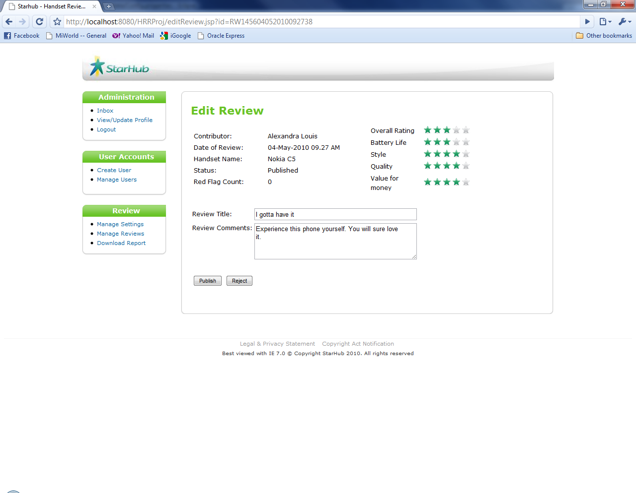

Figure 4.7.2.2: Edit Review page

### Edit Review

Step 1: In the ***Review Title*** textbox, edit review title.

Step 2: In the ***Review Comments*** textbox, edit review comments.

Step 3: Click on ***Publish*** button to edit review *(Figure 4.7.3.1)*.

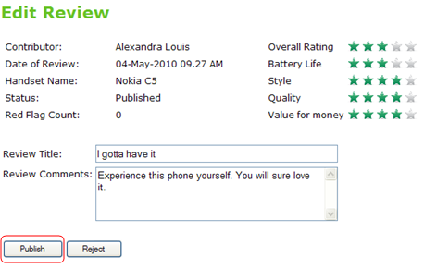

Figure 4.7.3.1: Edit review

A successful update of review message will be shown (Figure 4.7.3.2).

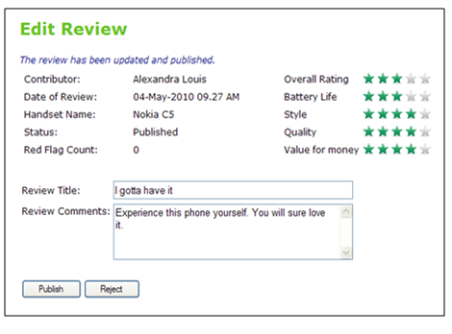

Figure 4.7.3.2: Successful Update of Review message

### Reject Review

Step 1: Click on ***Reject*** button to reject a particular review *(Figure 4.7.4.1)*.

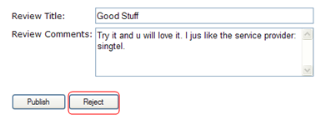

Figure 4.3.3.1: Reject button

Step 2: Click on the ***OK*** button to confirm *(Figure 4.7.4.2)*.

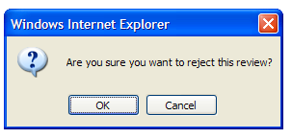

Figure 4.7.4.2: Reject review

An email will be sent to the contributor if review rejected due to inappropriate content.

## Download Report

There are 3 reports available.

**Summary of all mobile handset set** – generate rating by mobile handset from specific period of time. The report includes information:

* Mobile Handset
* Average Customer Rating
* Overall Rating
* Rating by classification

**Review by individual user** - list the reviews by particular user from specific period of time. The report includes information :

* Contributor name
* Review date
* Mobile Handset
* Review title
* Review Comment

**List of active user summary** – show the number of review posted by user. The report includes information :

* Contributor name
* Number of review posted

On the ***Review*** menu bar, click on ***Download Report*** *(Figure 4.8.1)*.

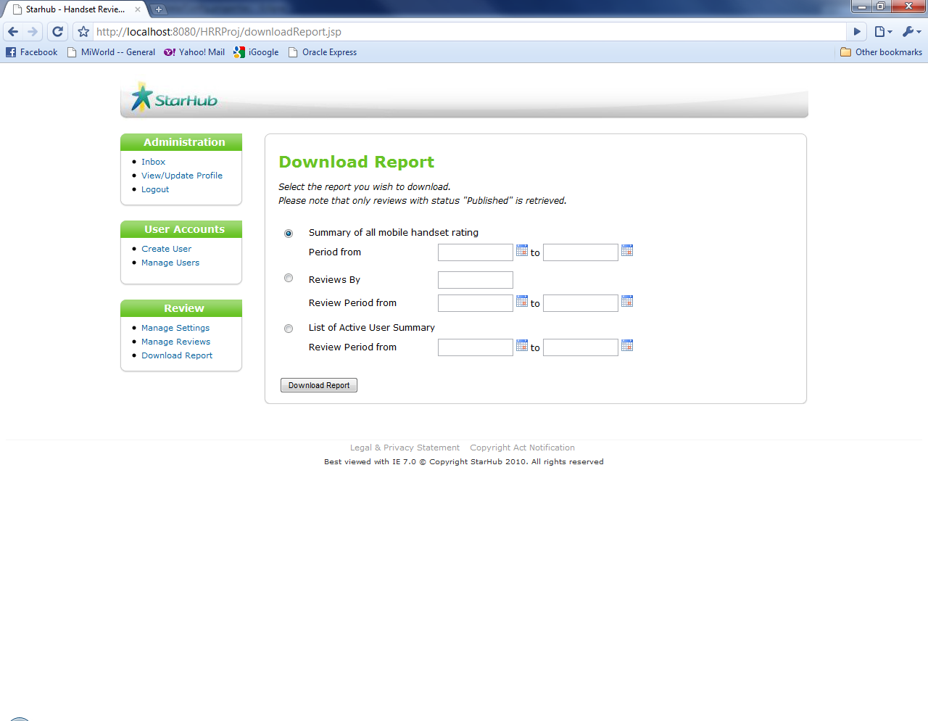  
Figure 4.8.1: Download Report page

Choose ***Summary of all mobile handset rating*** and choose the start and end date from the date picker icon.

**

Figure 4.8.2: *Summary of all mobile handset rating*

Click on ***Download Report*** button to download report *(Figure 4.8.7)*.

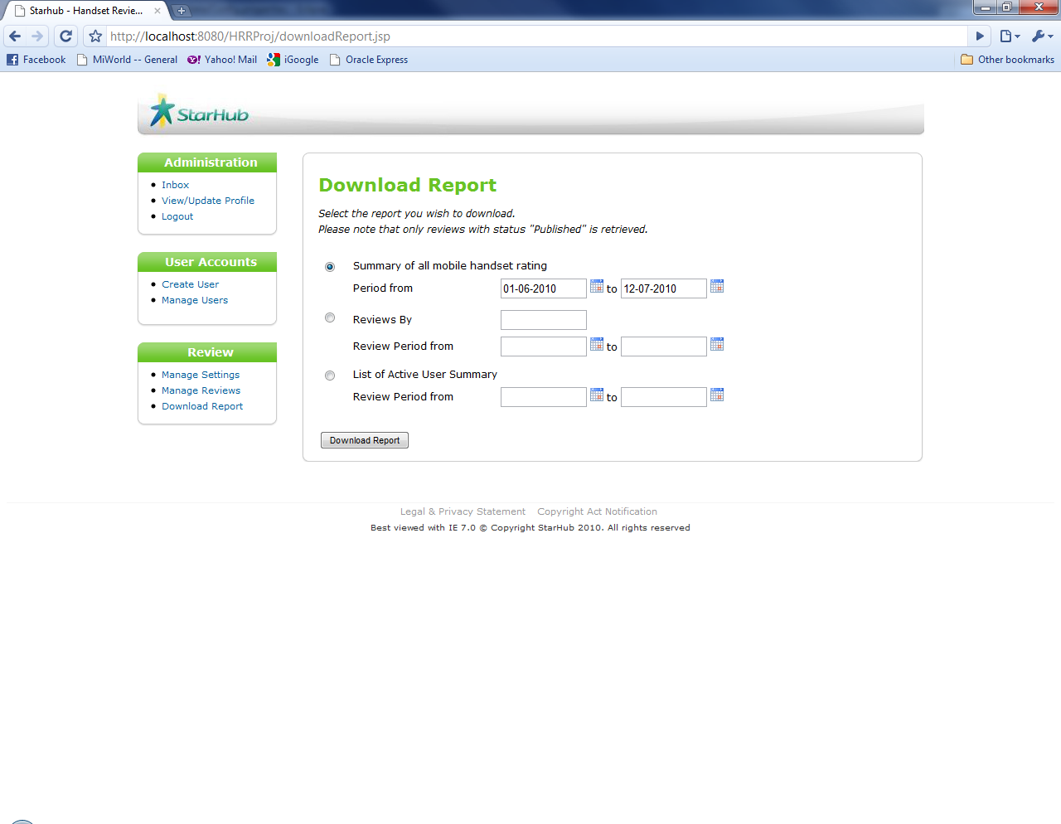

Figure 4.8.3: Download report

The report will be downloaded in Excel file format (Figure 4.8.8).

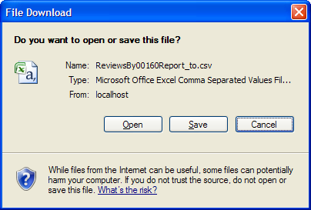

Figure 8.4: Save report

Choose ***Reviews By*** to generate the review by posted by particular user.

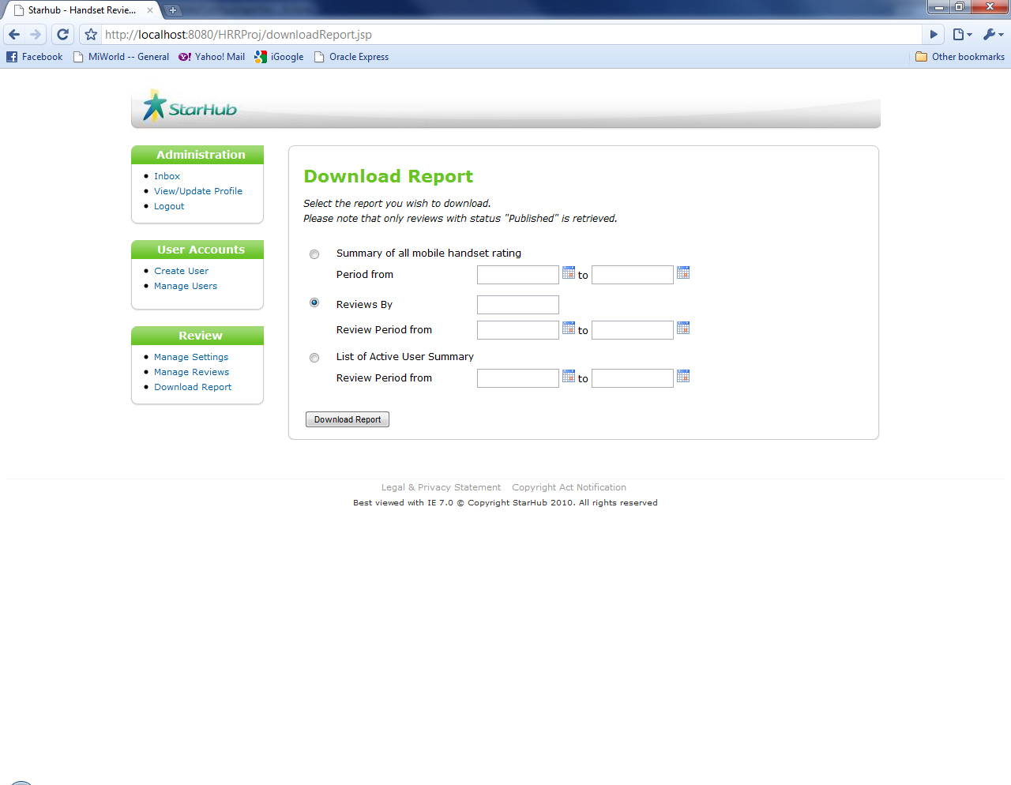

Figure 4.8.5: *Reviews By* user

Enter the name of the user who post the review in the textbox andselect the date range



Vincent

Figure 4.8.5: *Enter user name*

Choose ***List of Active User Summary*** to show numbers of reviews posted by users in particular date range. Select the date range from the date picker.

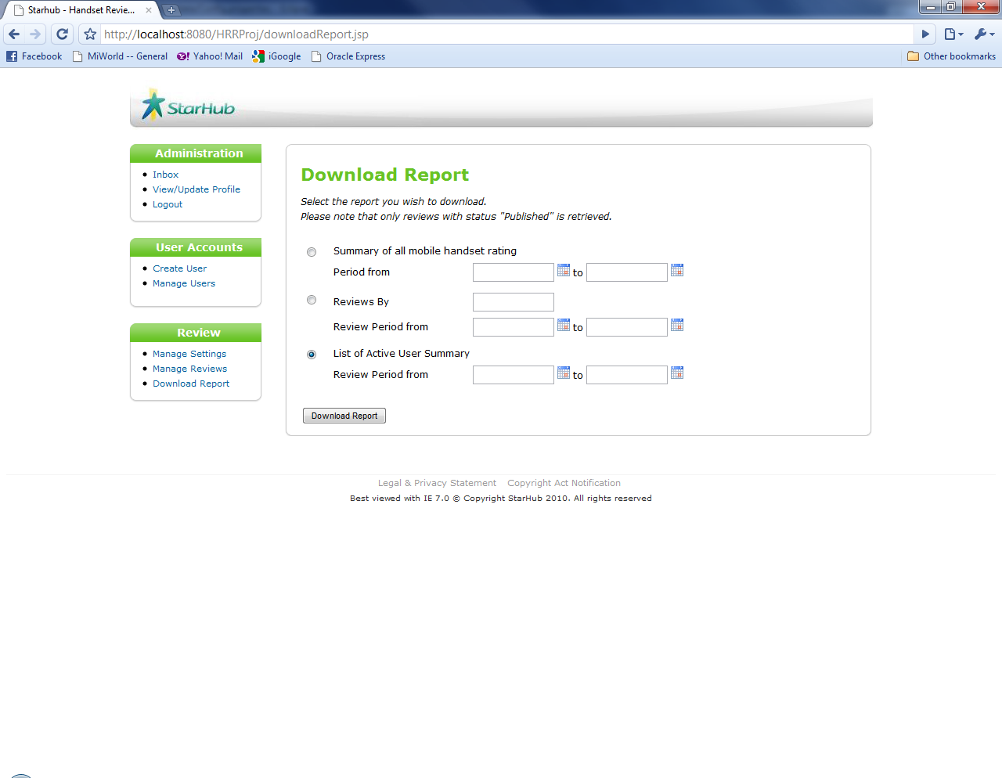

Figure 4.8.6: *List of Active User Summary*

## Logout

On the ***Administration*** menu bar, click on ***Logout*** to logout of the system*(Figure 4.9.1)*.



Figure 4.8.8: *Logout* hyperlink

**END OF DOCUMENT**